EXPERIMENT NO - 9
AIM: Write a program in C demonstrate the concept of page replacement policies for handling page faults eg: FIFO, LRU etc.
TOOLS/SOFTWARES REQUIRED: Windows OS
THEORY:
Page replacement:
Page replacement in operating systems is a memory management technique used when physical RAM is full, and a new page needs to be loaded from disk. It selects an existing page to "swap out" (evict) to make room for the new one. The primary goal is to minimize page faults to improve system performance.
Page replacement algorithms:
- FIFO: Replaces the oldest page, which was loaded into memory first.
- LIFO: Replaces the newest page, which was loaded into memory last.
- LRU: Replaces the page that has not been accessed for the longest period of time.

LIFO:
#include <stdio.h>

#define MAX_PAGES 100
#define MAX_FRAMES 10

int main() {
int reference_string[MAX_PAGES];
int frames[MAX_FRAMES];
int num_pages, num_frames;
int page_faults = 0;
int stack_top = -1; // Top of the stack (index of the most recent page in frames array)
int i, j;

// Get input from user
printf("Enter the number of frames (max %d): ", MAX_FRAMES);
scanf("%d", &num_frames);

printf("Enter the number of pages in the reference string (max %d): ", MAX_PAGES);
scanf("%d", &num_pages);

printf("Enter the reference string: ");
for (i = 0; i < num_pages; i++) {
scanf("%d", &reference_string[i]);
}

// Initialize frames to -1 (indicating empty)
for (i = 0; i < num_frames; i++) {
frames[i] = -1;
}

printf("\nPage Reference | Frames (LIFO)\n");
printf("--------------------------------\n");

for (i = 0; i < num_pages; i++) {
int current_page = reference_string[i];
int page_found = 0;

// Check if the page is already in the frames
for (j = 0; j < num_frames; j++) {
if (frames[j] == current_page) {
page_found = 1;
break;
}
}

if (!page_found) {
// Page fault occurs
page_faults++;

// If frames are not full, add the page to the next available frame (effectively pushing to stack)
if (stack_top + 1 < num_frames) {
stack_top++;
frames[stack_top] = current_page;
} else {
// If frames are full, replace the LIFO page (the one at stack_top)
frames[stack_top] = current_page;
}
}

// Print current state of frames
printf("%d\t\t|", current_page);
for (j = 0; j < num_frames; j++) {
if (frames[j] != -1) {
printf(" %d", frames[j]);
} else {
printf(" -");
}
}
printf("\n");
}

printf("\nTotal Page Faults: %d\n", page_faults);

return 0;
}
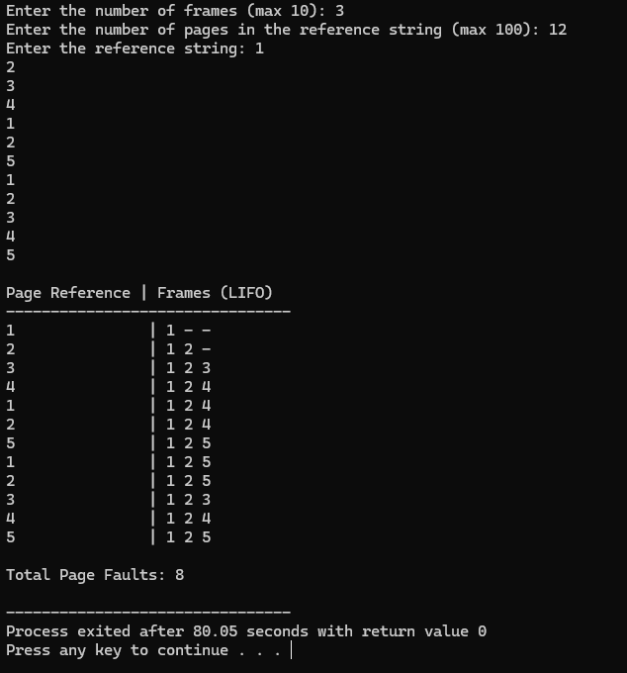

FIFO:
#include <stdio.h>

int main() {
int n, m, i, j, flag, page_faults = 0, first_in_index = 0;
int reference_string[30], frames[10];

printf("Enter number of pages: ");
scanf("%d", &n);

printf("Enter the reference string: ");
for (i = 0; i < n; i++)
scanf("%d", &reference_string[i]);

printf("Enter number of frames: ");
scanf("%d", &m);

// Initialize frames with -1 to indicate they are empty
for (i = 0; i < m; i++)
frames[i] = -1;

printf("\nRef String\tFrame Contents\n");

for (i = 0; i < n; i++) {
flag = 0;

// Check for Page Hit
for (j = 0; j < m; j++) {
if (frames[j] == reference_string[i]) {
flag = 1;
break;
}
}

// Page Fault logic
if (flag == 0) {
// Replace the oldest page (at first_in_index)
frames[first_in_index] = reference_string[i];

// Move the index to the next frame (circularly)
first_in_index = (first_in_index + 1) % m;
page_faults++;
}

// Display progress
printf("%d\t\t", reference_string[i]);
for (j = 0; j < m; j++) {
if (frames[j] != -1)
printf("%d ", frames[j]);
else
printf("- ");
}
if (flag == 0) printf("(Fault)");
else printf("(Hit)");
printf("\n");
}

printf("\nTotal Page Faults: %d\n", page_faults);
return 0;
}
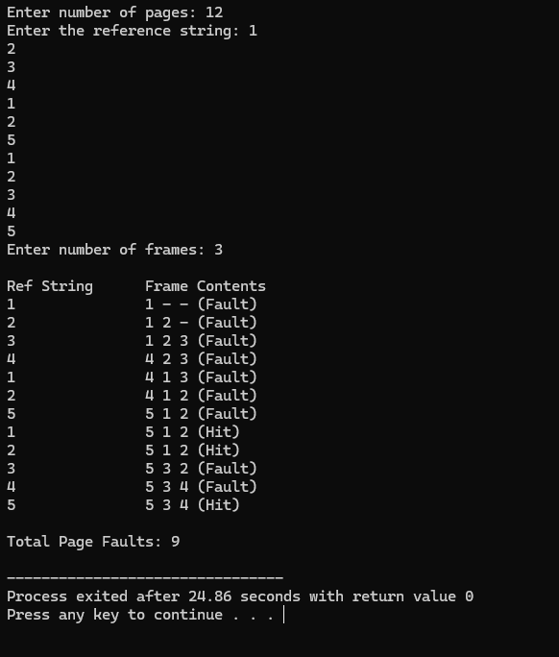

LRU (using stack):
#include <stdio.h>

#define MAX_FRAMES 10

// Function to find if a page exists in the current frames
int isPageInFrames(int frames[], int n, int page) {
int i;
for (i = 0; i < n; i++) {
if (frames[i] == page) return i;
}
return -1;
}

// Function to move a page to the "top" of the stack (most recent position)
void moveToTop(int frames[], int n, int index) {
int i;
int temp = frames[index];
// Shift all elements above the index down by one
for (i = index; i < n - 1; i++) {
frames[i] = frames[i + 1];
}
frames[n - 1] = temp;
}

int main() {
int n_pages, n_frames, page_faults = 0, i, j;
int pages[30], frames[MAX_FRAMES];
int current_frame_count = 0;

printf("Enter number of pages: ");
scanf("%d", &n_pages);

printf("Enter reference string: ");
for (i = 0; i < n_pages; i++) {
scanf("%d", &pages[i]);
}

printf("Enter number of frames: ");
scanf("%d", &n_frames);

// Initialize frames with -1
for (i = 0; i < n_frames; i++) frames[i] = -1;

printf("\nRef String | Frames\n");
printf("-----------|-----------\n");

for (i = 0; i < n_pages; i++) {
int page = pages[i];
int pos = isPageInFrames(frames, current_frame_count, page);

if (pos != -1) {
// Page Hit: Move the existing page to the top
moveToTop(frames, current_frame_count, pos);
} else {
// Page Fault
page_faults++;
if (current_frame_count < n_frames) {
// If there's space, just add to the top
frames[current_frame_count] = page;
current_frame_count++;
} else {
// Stack is full: Remove bottom (index 0) and push new to top
for (j = 0; j < n_frames - 1; j++) {
frames[j] = frames[j + 1];
}
frames[n_frames - 1] = page;
}
}

// Display current frames
printf(" %d | ", page);
for (j = 0; j < n_frames; j++) {
if (frames[j] != -1) printf("%d ", frames[j]);
else printf("- ");
}
printf("\n");
}

printf("\nTotal Page Faults: %d\n", page_faults);
return 0;
}
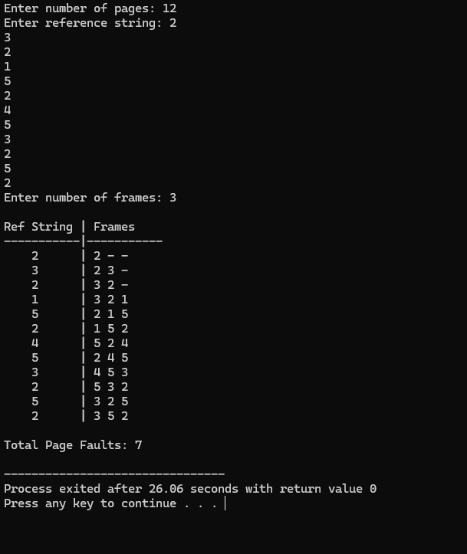

CONCLUSION: Hence, we have learned about the concept of page replacement in OS, a memory management technique used when the RAM is full. We have also seen it’s different algorithms and implemented them using C language.

